# Hulubul Landing Page — QA Notes and Issues

Date: 14 May 2026
Tested by: Adrian
Scope: Landing page content update and basic functional testing
Environment: Public website and Strapi admin panel

## Summary
The landing page content was updated based on Andrei’s document.
During the review, several issues were identified.
This document lists the issues that should be checked and fixed before confirming the page as ready for the campaign.

## Issues Found
—-----
### Issue 01 — Sender CTA does not open the correct registration page

Area: Landing page / “For whom” section
Priority: Medium
Status: Open

What happens:
When the user clicks “Mă înscriu ca expeditor”, the button does not open the expected registration page.

Expected result:
The button should open the sender registration / survey page.

Actual result:
The click does not redirect the user correctly.

Screenshot:
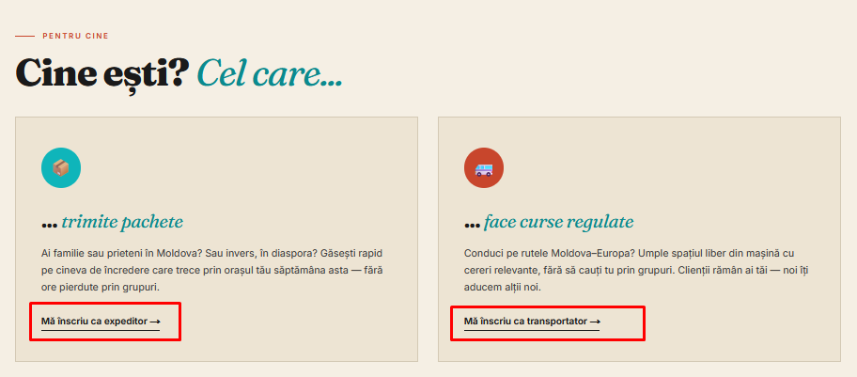

Notes:
In Strapi, the link should be checked in the `linkHref` field.

—-----------------

## Issue 02 — Waitlist form submission fails for all user roles

Area: Landing page / Waitlist form
Priority: High
Status: Open

### What was tested

The waitlist form was tested for all available user roles:

- Sender — `Trimit pachete`
- Receiver — `Primesc pachete`
- Transporter — `Sunt transportator`

In all cases, the form was completed with name, email, WhatsApp number, route / city information, device retention selected, and privacy agreement selected.

### What happens

After clicking `Mă înscriu pe listă`, the form does not submit successfully.

The same error is displayed for all three user roles:

`Strapi /api/waitlist-submissions failed: 400`

### Expected result

The form should submit successfully for each user role.

A confirmation message should be shown to the user, and the submitted data should be saved in Strapi / backend.

### Actual result

The form shows a 400 error and the submission is not completed.

This currently blocks the main waitlist flow on the landing page.

### Screenshots

Screenshot 1 — Sender role: [add screenshot here]
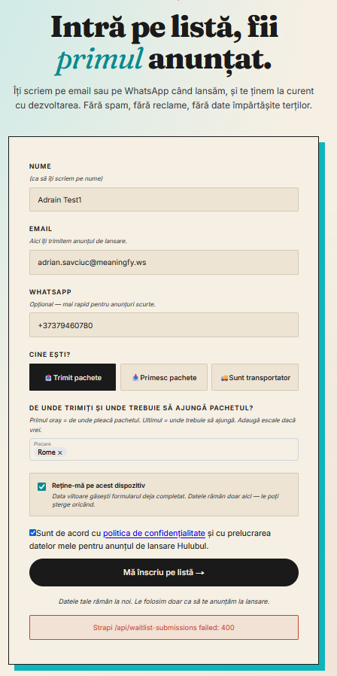

Screenshot 2 — Receiver role: [add screenshot here]
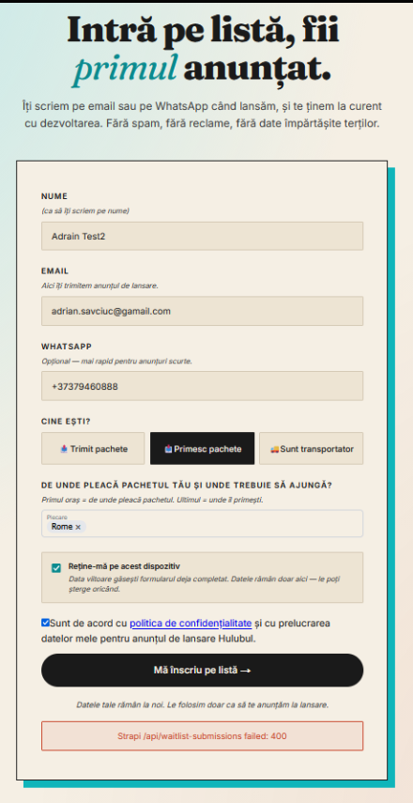

Screenshot 3 — Transporter role: [add screenshot here]
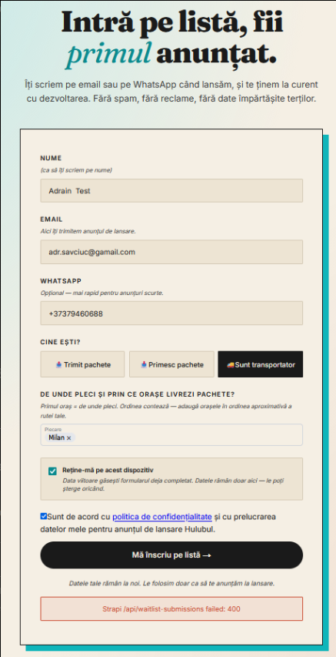
### Notes

This looks like a general submission issue, not a role-specific issue.

Recommended check: review the request sent to `/api/waitlist-submissions` and confirm that the frontend payload matches the fields expected by Strapi.

## Issue 03 — “View our map” CTA redirects to the top of the landing page

Area: Landing page / FAQ section
Priority: Medium
Status: Open

### What was tested

The CTA link `Vezi harta noastră →` was clicked in the FAQ section, under the question `Ce rute operăm?`.

### What happens

After clicking the link, the user is redirected to the top of the landing page.

### Expected result

The link should open the route map or a dedicated page / section where the user can see the available routes.

### Actual result

The link does not open a map or a relevant route section. It only redirects the user to the top of the landing page.

### Screenshot

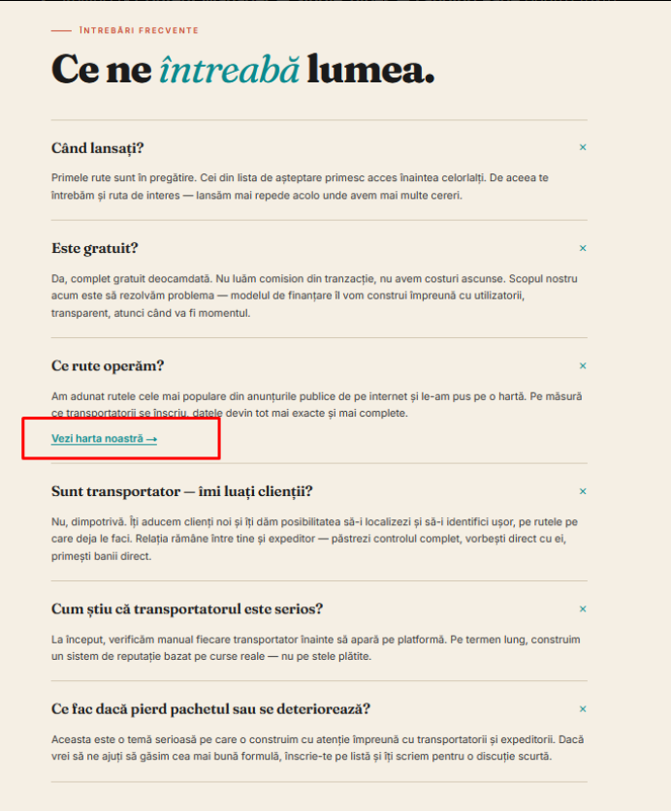

### Notes

If the route map is not ready yet, we should either remove this CTA temporarily or replace it with a link to the waitlist section.

Recommended content adjustment:

- Remove `Vezi harta noastră →` for now; or
- Change it to `Anunță-mă când lansăm rutele →` and link it to the waitlist section.

## Issue — Landing page Privacy and Terms footer links do not open legal pages

Area: Landing page / Footer / Legal links
Priority: Medium
Status: Open

### What was tested

The footer links `Confidențialitate` and `Termeni` were clicked on the landing page.

### What happens

After clicking these links, the expected legal pages do not open.

### Expected result

The links should open the relevant legal pages:

- Privacy Policy / `Confidențialitate`
- Terms and Conditions / `Termeni`

### Actual result

The links are visible in the footer, but they do not open the expected legal pages.

### Screenshot

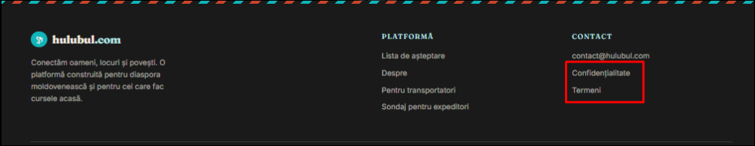

### Notes

This issue was also observed on the sender survey page.
It may be related to the same footer component or missing legal pages.

Recommended short-term fix:

- create simple placeholder pages for Privacy Policy and Terms; or
- temporarily remove the links until the pages are ready; or
- connect the links to the correct legal pages if they already exist.

## Sender Survey Page Issues

—----------------------------

## Issue — Footer navigation links are inactive or misconfigured

Area: Footer / Navigation links
Priority: Medium
Status: Open

### What was tested

The footer navigation links were clicked:

- `Lista de așteptare`
- `Despre`
- `Confidențialitate`
- `Termeni`

### What happens

Some footer links do not open the expected page or section.

`Lista de așteptare` and `Despre` do not redirect the user to relevant content.
`Confidențialitate` and `Termeni` redirect to the top of the sender survey page instead of opening legal pages.

### Expected result

Each footer link should open the correct destination:

- `Lista de așteptare` should open the waitlist section on the landing page.
- `Despre` should open the About page or About section.
- `Confidențialitate` should open the Privacy Policy page.
- `Termeni` should open the Terms page.

### Actual result

The footer links are not correctly connected and do not provide the expected navigation.

### Screenshot

Screenshot 1 — Footer navigation links: [add screenshot here]

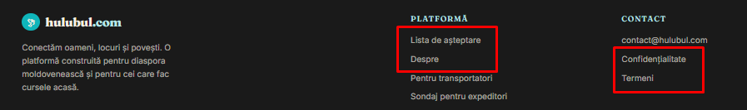

Screenshot 2 — Result after clicking one of the inactive links: [add screenshot here]
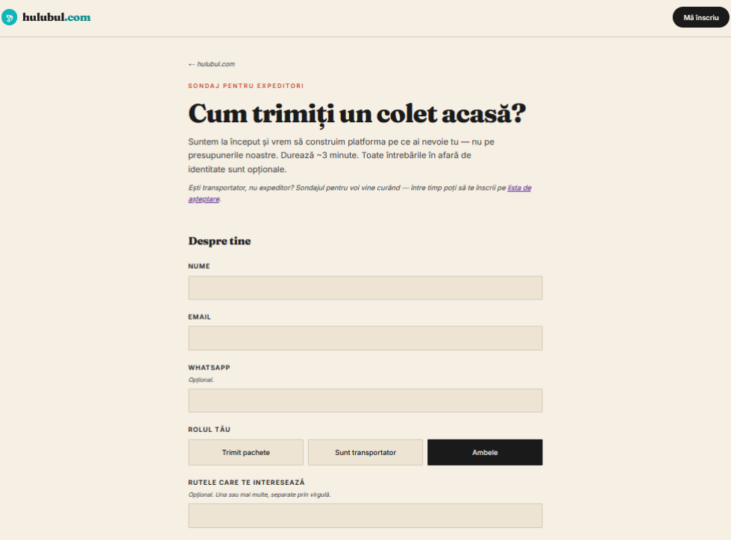
### Notes

Recommended short-term fix:

- connect `Lista de așteptare` to the waitlist section;
- connect `Despre` to the About page, if available;
- create simple placeholder pages for Privacy Policy and Terms, or temporarily remove these links until the pages are ready.

—----

## Issue — Header “Mă înscriu” button has no effect

Area: Header / CTA button
Priority: Medium
Status: Open

### What was tested

The header button `Mă înscriu` was clicked on the sender survey page.

### What happens

After clicking the button, nothing happens. The page does not move, and the user is not redirected to any form or section.

### Expected result

The button should redirect the user to the main waitlist / registration form on the landing page.

Expected target: landing page waitlist section.

### Actual result

The button has no visible effect.

The user stays on the same page, and no registration form is opened.

### Screenshot

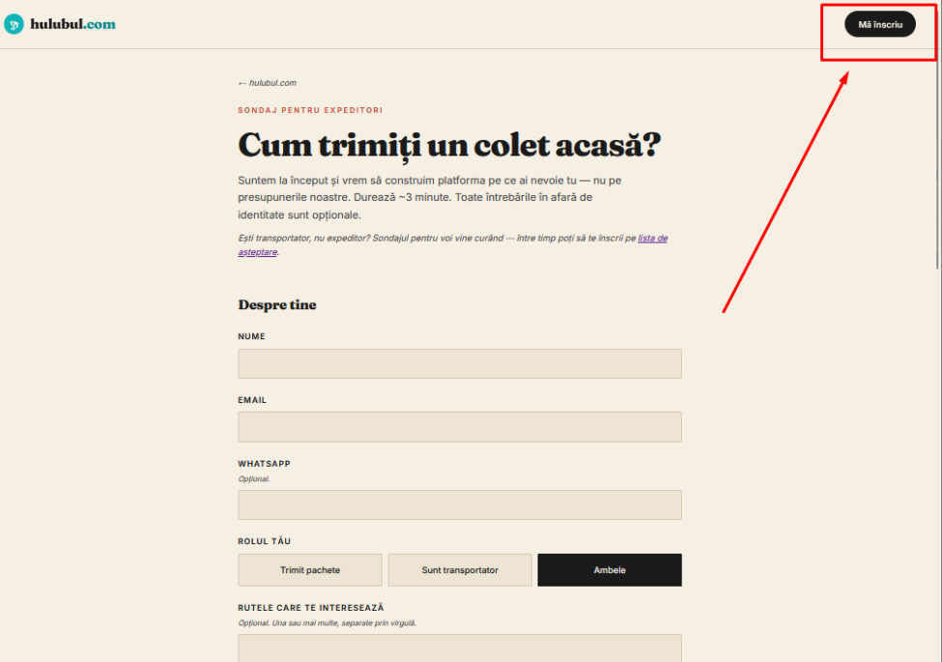

### Notes

Recommended short-term fix: link this button to the waitlist section on the landing page.

Suggested target: `/#signup` or the correct landing page anchor used for the waitlist form.

If this CTA is not needed on the sender survey page, it should be removed to avoid confusion.

—------
## Issue 05 — Sender survey form submission fails with 405 error

Area: Sender survey page / Survey form
Priority: High
Status: Open

### What was tested

The sender survey form was completed on the page `Sondaj pentru expeditori`.

The form was filled in with user details, route information, context answers, transporter selection behaviour, trust signals, pain points, and final consent / contact preferences.

### What happens

After clicking `Trimite răspunsurile`, the form does not submit successfully.

The following error is displayed:

`Strapi /api/survey-responses failed: 405`

### Expected result

The survey form should submit successfully and show a confirmation message.

The submitted survey response should be saved in Strapi / backend.

### Actual result

The form shows a 405 error and the survey response is not submitted.

This blocks the sender survey flow.

### Screenshot

Screenshot 1 — Top part of completed survey: [add screenshot here]
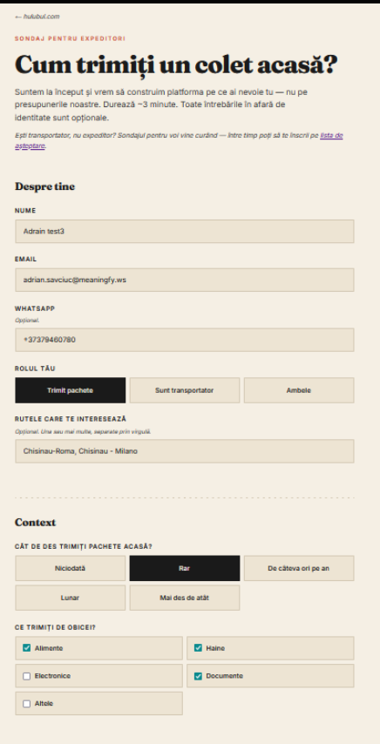
Screenshot 2 — Middle part of completed survey: [add screenshot here]
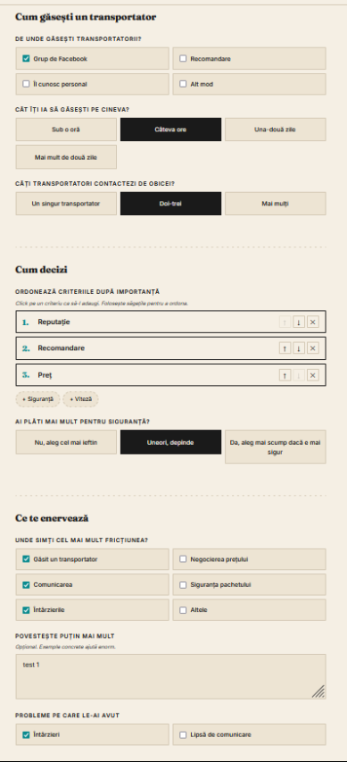

Screenshot 3 — Submit error: [add screenshot here]
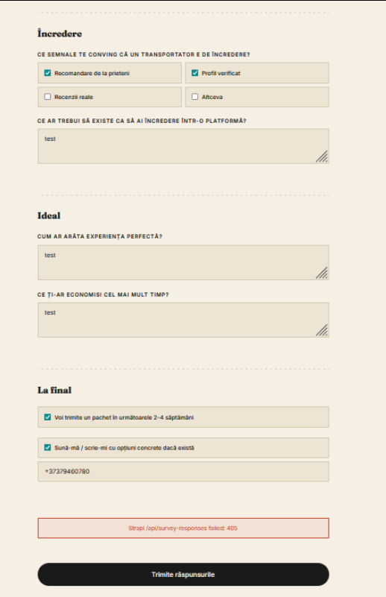

### Notes
This may be related to the API method or route configuration for `/api/survey-responses`.

Recommended check: verify that the frontend request method and endpoint match what Strapi expects for creating survey responses.

## Issue — Survey questions do not change based on selected user role

Area: Sender survey page / Role selection and questionnaire logic
Priority: Medium
Status: Open

### What was tested

The survey page was tested by selecting different user roles:

- `Trimit pachete`
- `Sunt transportator`
- `Ambele`

### What happens

When selecting `Sunt transportator` or `Ambele`, the questionnaire content does not change.

The form still shows questions mainly focused on the sender experience. There are no clearly relevant questions for transporters, mixed-role users, or people who receive parcels.

### Expected result

The questionnaire should adapt based on the selected user role, or the available role options should match the real scope of the survey.

### Actual result

The selected role changes visually, but the questionnaire remains mostly focused on the sender flow.

This may confuse users and may lead to irrelevant survey responses.

### Screenshots

Screenshot 1 — Transporter role selected: [add screenshot here]
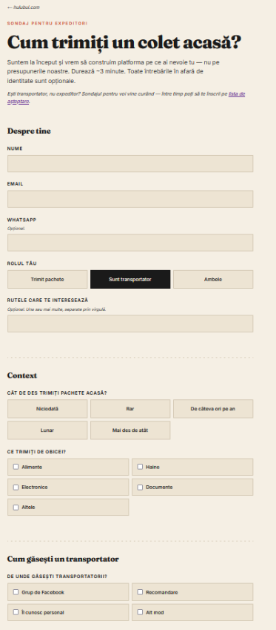

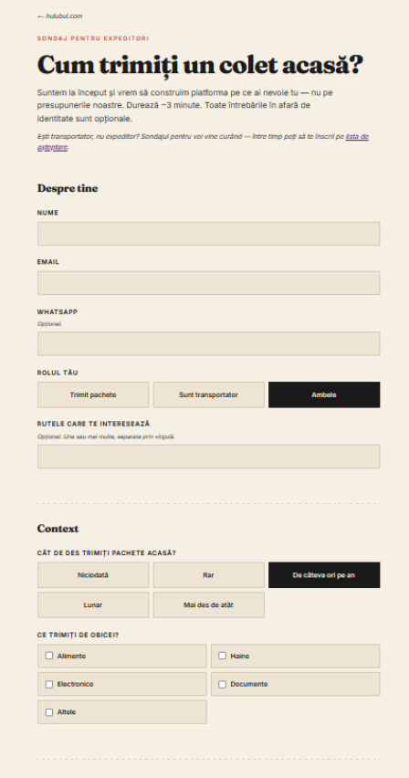
Screenshot 2 — Both role selected: [add screenshot here]
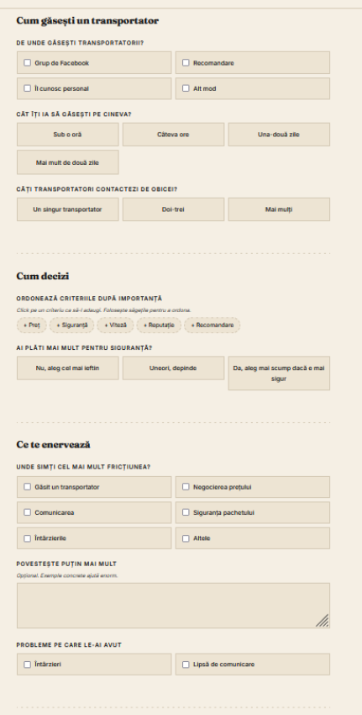

Screenshot 3 — Sender-focused questions still visible: [add screenshot here]
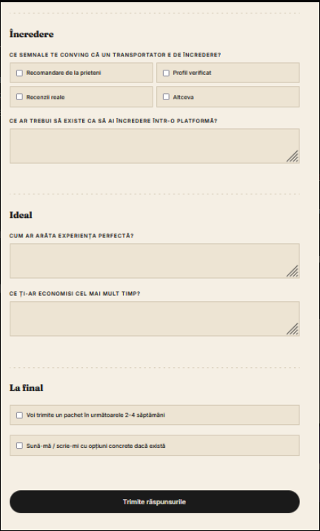

### Notes
If this survey is intended only for senders, the safest short-term option is to remove or disable the `Sunt transportator` and `Ambele` options.

If we want to collect data from all roles, the form needs separate question logic for senders, transporters, and receivers.

